**VIRTUAL HOST**

**NOMBRE:** ESTEFANIA PILAMUNGA

**BLOC DE NOTAS**

sudo setenforce 0

getenforce

mkdir -p /var/www/johannapilamunga.com/html

mkdir -p /var/www/estefaniaaguilar1518.com/html

chown -R apache:apache /var/www/johannapilamunga.com/

chown -R apache:apache /var/www/estefaniaaguilar1518.com/

chmod -R 755 /var/www/

sudo nano /var/www/johannapilamunga.com/html/index.html

sudo nano /var/www/estefaniaaguilar1518.com/html/index.html

sudo nano /etc/httpd/conf/httpd.conf

<Virtualhost *:80>

ServerName www.johannapilamunga.com

ServerAlias johannapilamunga.com

DocumentRoot /var/www/johannapilamunga.com/html

ErrorLog /var/www/johannapilamunga.com/error.log

CustomLog /var/www/johannapilamunga.com/request.log combined

</VirtualHost>

<VirtualHost *:80>

ServerName www.estefaniaaguilar1518.com

ServerAlias estefaniaaguilar1518.com

DocumentRoot /var/www/estefaniaaguilar1518.com/html

ErrorLog /var/www/estefaniaaguilar1518.com/error.log

CustomLog /var/www/estefaniaaguilar1518.com/request.log combined

</VirtualHost>

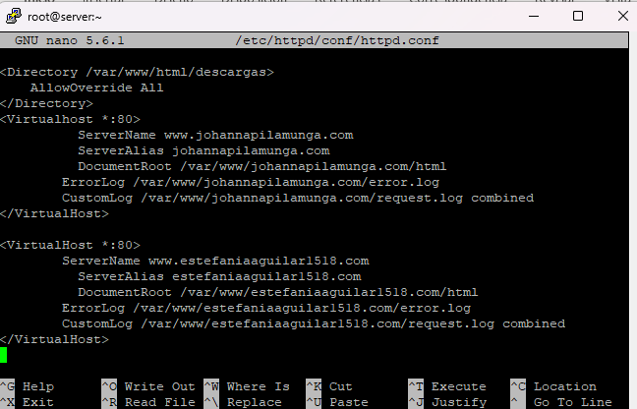

windows

worpad como administrador

C:\Windows\System32\drivers\etc\

agregar la ip con los dominios

192.168.9.133 www.estefaniaaguilar1518.com www.johannapilamunga.com

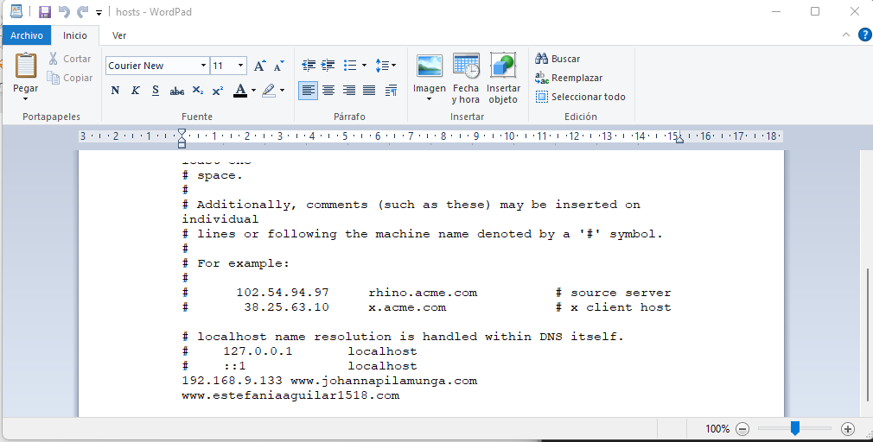

systemctl restart httpd

y se verifica el dominio 1



y el dominio 2

